**Web Apps with Rust: Your Guide to a Sleek, Fast Application**

Ready to build something extraordinary?

[[Bits Kingdom](https://medium.com/@bitskingdom?source=post_page-----fb2986e80356--------------------------------)](https://medium.com/@bitskingdom?source=post_page-----fb2986e80356--------------------------------)

[[X-periment Asteroid](https://medium.com/x-periment-asteroid?source=post_page-----fb2986e80356--------------------------------)](https://medium.com/x-periment-asteroid?source=post_page-----fb2986e80356--------------------------------)

[Bits Kingdom](https://medium.com/@bitskingdom?source=post_page-----fb2986e80356--------------------------------)

·

Follow

Published in

[X-periment Asteroid](https://medium.com/x-periment-asteroid?source=post_page-----fb2986e80356--------------------------------)

·

4 min read

·

Dec 29, 2023

3

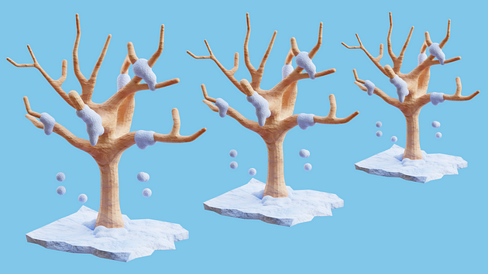

**Empower Your Web Development with Rust: The Future of Web Apps**

Step into the forefront of web app development! Embrace the strength of Rust, a programming language revolutionizing web applications. Together, let’s unlock the power of Rust and its incredible capabilities.

**Rust and Leptos: A Dynamic Duo for Web Development**

Rust is celebrated for its safety and speed, revolutionizing web app development. Combined with Leptos, reminiscent of [JavaScript](https://bitskingdom.com/blog/optimizing-javascript-speed-strategies/) frameworks like Solid, React, and Svelte, and Rust’s own Yew and Dioxus, Rust elevates its game. This duo makes Rust powerful and accessible, especially for those familiar with these frameworks.



**Installing Rust: Your Gateway to Web App Innovation**

Rust installation is your first step towards web development marvels, regardless of your operating system preference:

* **Windows Users**: Opt for the Windows Subsystem for Linux (WSL) or Rust’s official installer.
* **macOS Enthusiasts:** Utilize Homebrew, a package manager, for installing Rust.
* **Linux Advocates**: Install Rust through package managers or the official installer.

**Begin your Rust journey:**

* Open a terminal.
* Download the installer:
* For Linux and macOS: curl --proto '=https' --tlsv1.2 -sSf https://sh.rustup.rs | sh
* For Windows: Download and execute the installer from Rust’s website.
* Follow the installation instructions, including adding Rust to your system’s PATH.
* Verify your installation with rustc --version and cargo --version in a new terminal window.

**Installing Trunk: Enhancing Your Rust Experience**

Trunk, a web assembly application bundler for Rust, is your next step. Install Trunk via Cargo and confirm its installation:

* Open a terminal.
* Install Trunk with cargo install trunk.
* Verify the installation with trunk --version.

**Starting Your Project with Cargo**

Cargo streamlines the creation and management of your new Rust project:

* Open a terminal.
* Create your project: cargo init awesome-web-app. Cargo will create a new directory with this name and set up a basic Rust project structure inside.
* Navigate to the new directory: cd awesome-web-app.
* Familiarize yourself with Cargo’s default project structure, including the src/ directory and Cargo.toml

**Integrating Leptos into Your Project**

Easily integrate Leptos into your project:

* In your terminal, in the project directory, add Leptos as a dependency with cargo add leptos --features=csr. This command adds the Leptos crate to your project with the specified feature, "csr".
* Update dependencies with cargo update: Upon adding the Leptos crate, Cargo automatically updates your cargo.toml file with the new dependency entry.

**Adding the wasm32-unknown-unknown Target**

To compile code to WebAssembly for browser compatibility:

* Ensure Rustup is installed.
* Add the target: rustup target add wasm32-unknown-unknown.
* Verify the addition with rustup target list.

**Building Your App with Leptos:**

Start by creating a basic index.html in your project’s root directory:

<!DOCTYPE html>  
<html>  
 <head></head>  
 <body></body>  
</html>

Add a “Hello, world!” message in main.rs:

use leptos::*;

fn main() {  
 mount_to_body(|| view! { <p>"Hello, world!"</p> })  
}

Launch and view your app at <http://127.0.0.1:8080/> with trunk serve --open.

**Adding Interactivity: The Rust Way**

Let’s spice things up with an interactive counter component.

* Define a Button component in main.rs that updates a counter when clicked.
* Implement the counter logic using Rust’s create_signal function.

use leptos::*;

#[component]  
fn Button() -> impl IntoView {  
 let (count, set_count) = create_signal(0); let handle_counter = move |_| {  
 set_count.update(|n| *n += 2);  
 }; view! {  
 <div>  
 <h2>{move || count.get()}</h2>  
 <button on:click=handle_counter>"Click me!"</button>  
 </div>  
 }  
}

The App component is composed of a header stating “Rust is Awesome” and an instance of the Button component.

...

#[component]  
fn App() -> impl IntoView {  
 view! {  
 <h1>"Rust is Awesome"</h1>  
 <Button />  
 }  
}...

Here is the full code, if you want to copy it:

use leptos::*;

#[component]  
fn Button() -> impl IntoView {  
 let (count, set_count) = create_signal(0); let handle_counter = move |_| {  
 set_count.update(|n| *n += 2);  
 }; view! {  
 <div>  
 <h2>{move || count.get()}</h2>  
 <button on:click=handle_counter>"Click me!"</button>  
 </div>  
 }  
}#[component]  
fn App() -> impl IntoView {  
 view! {  
 <h1>"Rust is Awesome"</h1>  
 <Button />  
 }  
}fn main() {  
 mount_to_body(App)  
}

**Styling Your App: The CSS Touch**

For that stylish look, add leptos_meta as a dependency and create a CSS file with your desired styles. Then, integrate these styles into your Rust components to bring them to life!

cargo add leptos_meta --features=csr

Now, create a css file style/output.css with this code:

body {  
 background-color: #0b0a11;  
 font-family: Arial, Helvetica, sans-serif;  
}

main {  
 margin: 0 auto;  
 max-width: 600px;  
 text-align: center;  
 color: white;  
}.counter {  
 display: flex;  
 flex-direction: column;  
 justify-content: center;  
}.counter button {  
 height: 40px;  
 width: 120px;  
 border: 0;  
 margin: 0 auto;  
}

Here is the full code:

use leptos::*;  
use leptos_meta::*;

#[component]  
fn Button() -> impl IntoView {  
 let (count, set_count) = create_signal(0); let handle_counter = move |_| {  
 set_count.update(|n| *n += 2);  
 }; view! {  
 <div class="counter">  
 <h2>{move || count.get()}</h2>  
 <button on:click=handle_counter>"Click me!"</button>  
 </div>  
 }  
}#[component]  
fn App() -> impl IntoView {  
 provide_meta_context(); view! {  
 <main>  
 <h1>"Rust is Awesome"</h1>  
 <Button />  
 </main>  
 }  
}fn main() {  
 mount_to_body(App)  
}

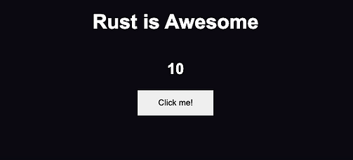

**Conclusion: The Power of Rust in Web Development**

You’ve now built a functional, stylish web application with Rust. This is just the beginning of your journey with Rust. Keep exploring and innovating to realize the full potential of your web develop